Oahe Family YMCA Tackle Football League

WHAT: A safe introduction to the rules, the skills and the game of tackle football. Games are played.

WHO: This program is open to 3rd – 7th grade boys and girls.

WHEN: Tackle football will meet Monday and Thursday evenings. Football begins Thursday, September 7th and runs through Thursday, October 19th. Coaches or the “Y” will call each player with time of practice.
If you do not receive a call by September 7th call the YMCA at 224-1683.

WHERE: Tackle football league will be held at the Oahe Softball Complex (800 South Buchanan).

REGISTER: At the YMCA, 900 East Church. Early Bird Registration begins May 1st and ends May 31st.
Regular Registration begins June 1st and ends July 31st. Late Registration will begin August 1st and ends August 7th.
Program is limited.

FEE: Early Bird: $60.00 members/$75.00 non-members. Regular: $70.00 members/$85.00 non-members.
Late: $80.00 members/$95.00 non-members.
***Financial assistance is available for those who qualify. Apply at the Oahe Family YMCA front desk. ***

EQUIPMENT: The player is responsible for providing their mouth piece (required), and shoes. All other equipment is provided by the Oahe Family YMCA but must be returned at the end of the season. Equipment check-out will be Monday, August 21st. Equipment must be returned on Wednesday October 25th or the player will be charged a late fee.
Coaches’ meeting/team draft will be Thursday, August 24th at 6:30pm in the YMCA classroom.

*Parents, most communications from the YMCA about this program will be by email and come from the following address, beth@oaheymca.org. Because these emails will be sent to the entire group registered for this program some filters send them to junk/spam so please add this address to your safe list. Also, please make sure to check your emails periodically during the season for updates/info on this program.
Form must be filled out completely! Please PRINT clearly.
Name____________________________________________________________________ Grade (Fall 2017)_____________

Date of Birth_________________ Age_______ YMCA member______ Non-member________

Address____________________________________________________ City_________________ Home #_____________________

Parent/Guardian’s names_______________________________________________________________________________________

Email address__________________________________________________________________________________(Please include*.)

Mom’s work__________________ M cell__________________ Dad’s work____________________ D cell____________________

PARENTS: We need your help! Our program’s size and success depends upon your volunteering to help coach, referee, etc. for our football practices/games. Please print your name below if you are interested in helping out with this year’s tackle football program.

PRINT NAME OF VOLUNTEER _____________________________________________________________________

I would like to: **Coach_______ Co-coach_______ Referee/Umpire_______ Time______ Chain Gang______ Equipment check out (Aug. 21st)______ Equipment check in (Oct. 25th)______
Game set up/take down_______ Pizza Ranch Fundraiser (Oct. 17th)_______.
**Coaches are required to attend a meeting on Thursday, August 24th at 6:30pm in the Y classroom - mark your calendar!

_____ Please order me a “Y”- Winners t-shirt. A t-shirt will cost an additional $10.00.
Order me a size (Circle one) YOUTH: M, L, or ADULT: S, M, L, XL.

____ I would like to donate to the purchase of new player equipment, practice equipment or field equipment. Please make a separate check. Amount enclosed __________. Thank you for your support!

WAIVER: In consideration of the YMCA’s acceptance of my participation in the above named program, I waive any and all claims for myself, and my heirs that I may have against the Oahe YMCA, its Board of Directors, Pierre Public Schools, employees, sponsors, officials, and volunteers for any injury or illness which may directly or indirectly result from my participation. The YMCA does not carry liability insurance; you are responsible for all injuries. I further state that I am in proper physical condition to participate in this program.
The Pierre and Stanley County School Districts neither endorse nor sponsor this organization or the activity represented in this document.
The distribution of this material is provided as a community service.

Guardian’s Signature_______________________________________________________________________________________________________________________
Tackle Football League
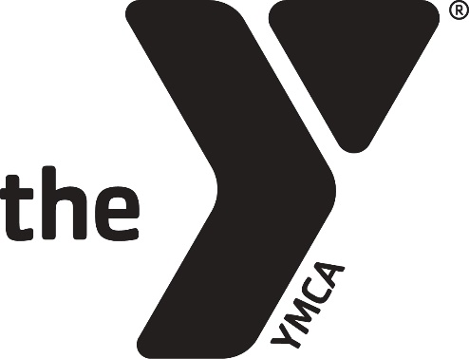

******************************************************************************************
YMCA Use only

Player’s Name____________________________________________Weight (Filled in at check out) ___________
EQUIPMENT Checked Out Checked In Cost

EQUIPMENT BAG #_________ _________ $15.00
HELMET __________ _________ $100.00

SHOULDER PADS __________ _________ $60.00

JERSEY __________ _________ $35.00

PANTS W/PADS __________ _________ $30.00

REPLACEMENT TOTAL OWED _______

READ CAREFULLY BEFORE SIGNING:
I (and my guardian) promise to do my very best to not lose and to take care of the above equipment that has been checked out to me. I will return all equipment, CLEAN, to the Oahe Family YMCA on the equipment return date. If I do not return the equipment on the scheduled date I will be charged a late fee until the equipment is returned. If I fail to return the equipment I will reimburse the YMCA the cost listed above for each piece not returned. I understand that if I do not return my equipment and do not pay the reimbursement fee I will no longer be allowed to play in the Oahe Family YMCA tackle football league.

Player’s Signature___________________________________________________________________________________________

Guardian’s Signature_________________________________________________________________________________________

